**Lab Practical #07:**

Study the application layer protocol DNS, DHCP, FTP.

**Practical Assignment #07:**

1. **Implement the application layer protocol DNS, DHCP, and FTP. Also check connectivity between them using ping command or PDU utility.**

* **DNS**

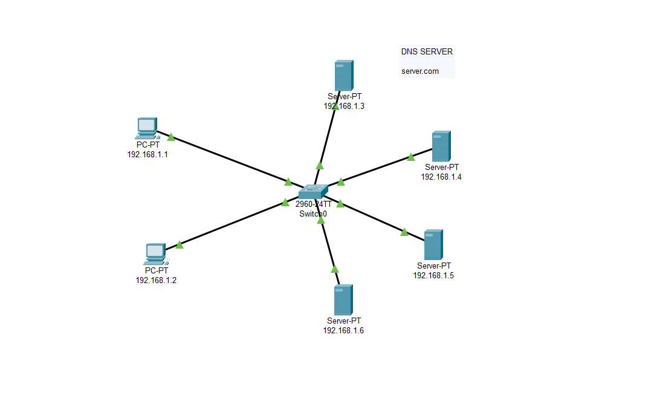

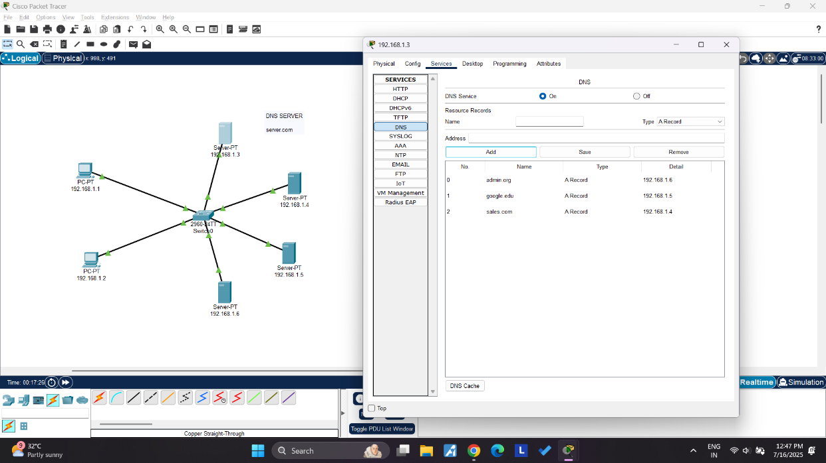

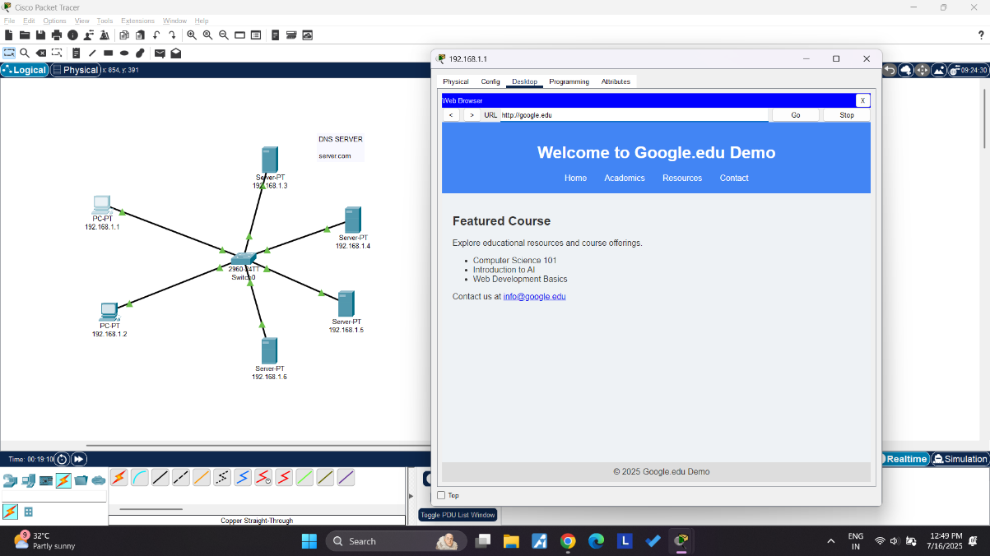

* **DHCP**

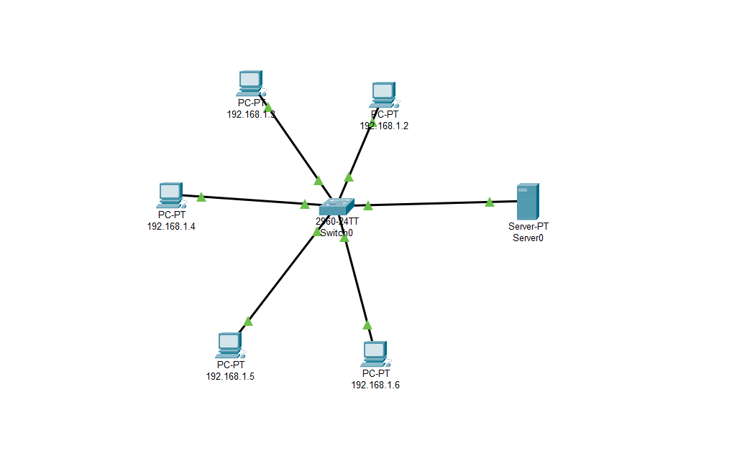

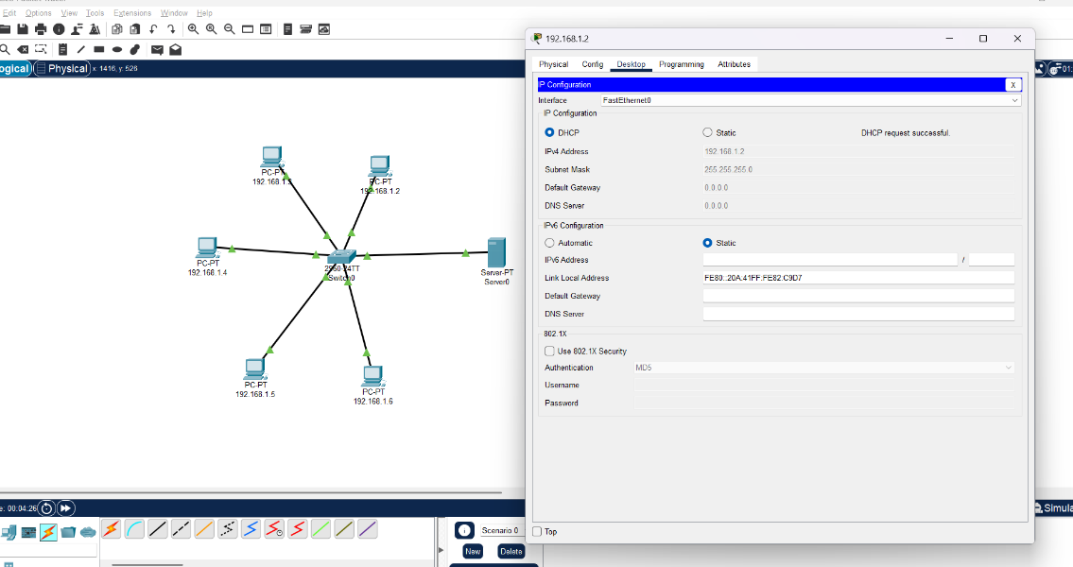

* **FTP**

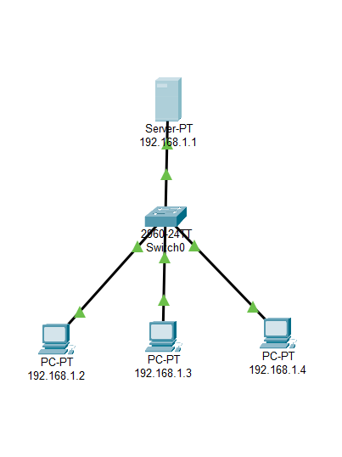

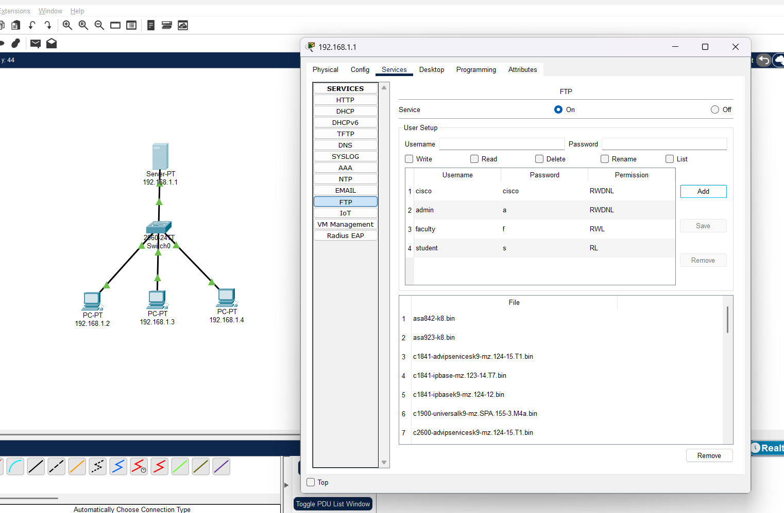

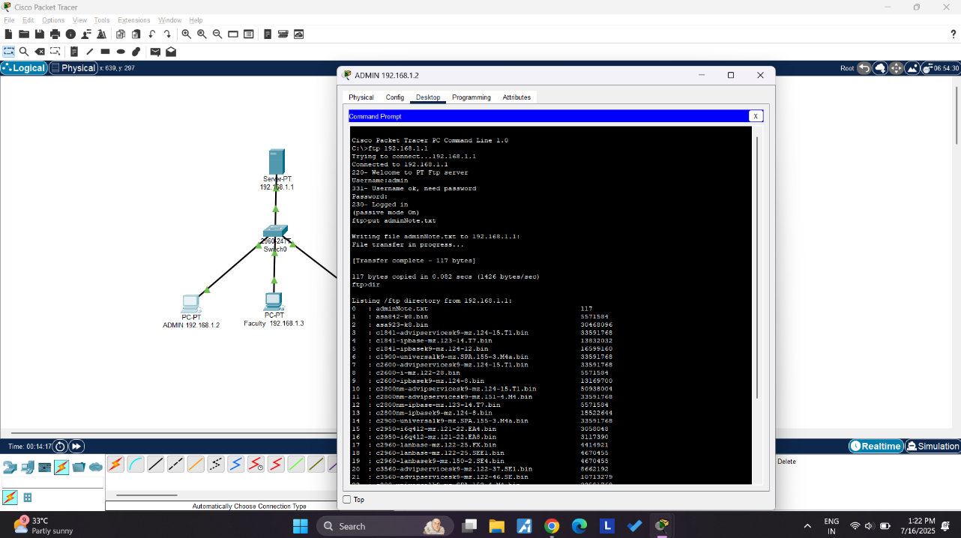

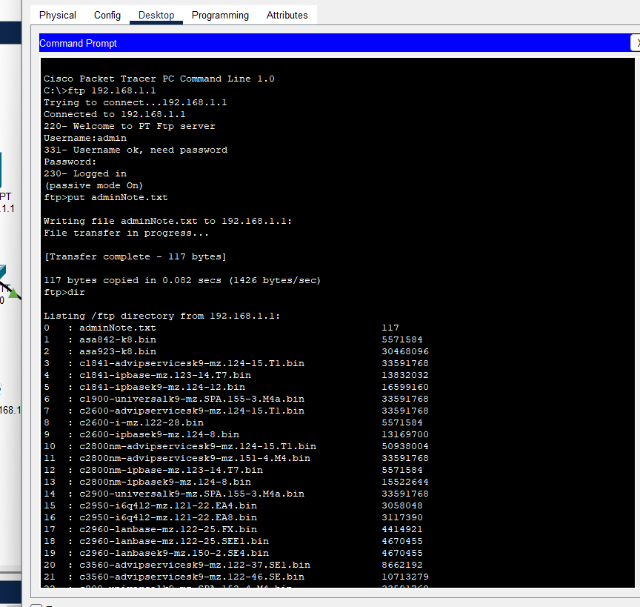

**Instructions:**

1. Protocol-wise configuration setup screenshot.
2. Mention IP address of each pc as label.
3. Ping command or PDU screenshot between two pcs.